Fletchers installation process

To access this network, use the following steps

To gain access, first download a Citrix Client/Plug-in from this site:
http://citrix.com/English/ss/downloads/results.asp?productID=186&c1=sot2755
Then browse to https://access.fletchers.net.au
Use the following:
Username - Adept
Password - DShjwns7

Network topology assumptions

Please use FLCANAD1 as the web server (with .net4)
A new website with host headers has been setup in readiness – commission.fletchers.com.au
Path is on d:\intetpub\commission.fletchers.com.au
For SQL Please use the default instance on FLCANSQL1 (not the console instance)

IIS Installation

- Add the files into the provided IIS directory. Setup the directory to use .NET 4 controls, creating its own app pool if required.
- Enable the .Net 4 object if disabled
- Install the Firebird connector to the DB (in the install directory) and configure a System ODBC connection using the following settings. (Password is: masterkey)

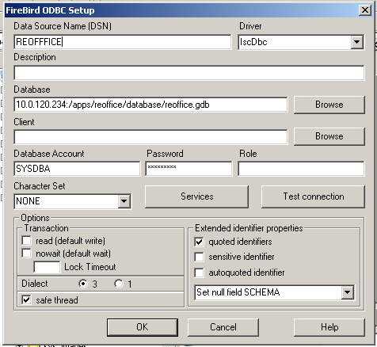

SQL installation

- Restore the DB and note the path: E:\SQL\Commissions
- This path will need to be backed up.
- Create the user that IIS is running in and set it as the db_owner.

